**CONDITIONAL PROBABILITY AND STOCHASTIC PROCESSES**

*Conditional Problem:*

* Probability of an event E when it is known that some other event F has occurred.
* One event happens, it affect ts the other one.
* Denoted by P(E|F)
  + “the conditional problem of E, given F.”
  + F is happened already, we are calculating probability of E according to it.

Example:

* P(guessing correct answer | A and B eliminated) = 1/3
* If you guess the answer to a multiple choice test with 5 choices. If you know A and B are wrong.

Example:

* Die is rolled (S = {1, 2, 3, 4 ,5 6}), you are told the number is > 3. Then F = {4, 5, 6}. This is reduced sample space.
* Prob. of getting an even number?
  + E = {2, 4, 6}
  + E F = {4, 6}
  + P(E | F) =

If E and F are events with equiprobable sample space and F then,

P(E | F) =

Since E F and E’ F disjoint,

P(E | F) + P(E’ | F) = 1

wrt the original sample space

Conditional probability of an event E given that F has occurred is:

P(E | F) =

We also have:

P(F | E) =

Then (general multiplication law):

P(E F) = P(E) . P(F | E)

= P(F) . (PE | F)

Example:

* After the initial run of a steel desk a quality control technician found that 40 % of the desk had an alignment problem and 10 % had both a defective paint job and an alignment problem.
* If a desk is randomly selected, from this run and it has an alignment problem, what is the prob that it also has a defective paint job?
* P(D | A) = P(D A) / P(A)
* A = {desks with alignment problem)
* D = {desks with defective paint job}
* P(D | A) = ?
* P(A) = 0.4
* P(D A) = 0.1
* P(D | A) = 0.1 / 0.4 = 1:4

*Stochastic Processes:*

* The sequence of trials is called a stochastic process.
* The probabilities of the events associated with each trial (beyond the first) could depend on what events occurred in the preceding trials, so they are conditional probabilities.
* For example football game prediction.
* Stochastic process is application of conditional probability.

Example (Cards and Probability Tree):

* 2 cards are drown one by one without replacement (don’t put it back) from a deck of cards. Find the probability that the both 1st and 2nd cards are red.
* A compound experiment of a sequence of 2 trials
* 1st: drawing a card
* 2nd: drawing a card after the first card has been drown.

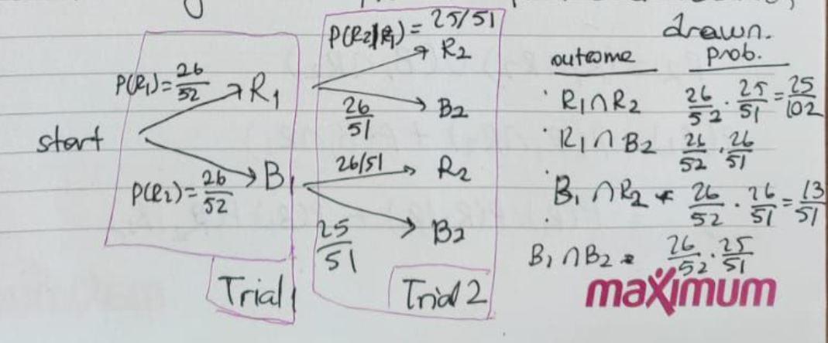

mutually exclusive, there are no card which has both colors.

* Picking the first card is not conditional, you just pick 1 card.
* After picking the first card, we know some knowledge. Depending on what we have, we can define the other step. Then, since we know sth, it changes the probability so it is now conditional.
* Since the second step depends on the previous step, this is also stochastic process.
* --------------------------------------------------------------------------------------------------------------------------------
* If you are asked what is the probability of 2nd card is red, then you have to add P(B1 R2) to 25/102.
* --------------------------------------------------------------------------------------------------------------------------------
* MATRIX SOLUTION:
  + Rows are first event, columns are second event.
  + When you add up values in rows or columns, they are all 1.

Note:

* P(E1 E2 E3 … En)
* = P(E1) . P(E2|E1) . P(E3|E1E2) … P(En|E1…En-1)
* Each time consider first one as the first event, rest as the second event.
* Order is not important but once you decide the order, you have to follow it.

Example (Jelly Beans in a bag):

* Bag 1 contains 1 black and 2 red jelly beans
* Bag 2 contains 1 pink jelly bean
* A bag is selected at random. Then a jelly bean is randomly taken from it and placed in the other bag. A jelly bean is then randomly taken from that bag.
* Find the probability that this jelly bean is pink.
* --------------------------------------------------------------------------------------------------------------------------------
* 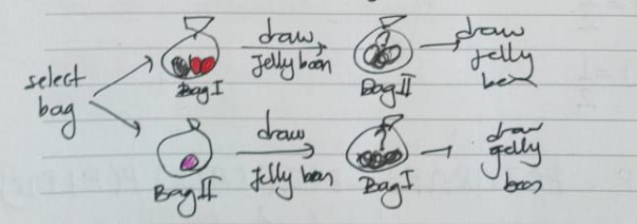
* 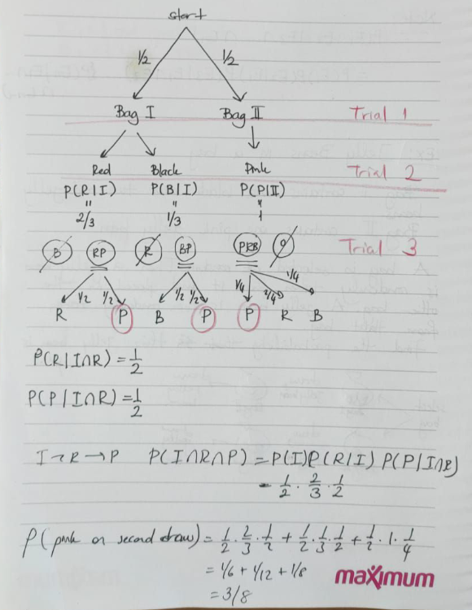
* After first step, conditional probability starts.

Independent Events

P(E | F) = P(E) -----> E is independent of F

P(E) 0 P(F)

The prob. of E doesn’t change even if F is occured.

Assume,

* P(F | E) = = = = P(F)

If E is independent of F, then F is independent of E.

Let E and F be events. Then E and F are said to be independent events if either:

* P(E | F) = P(E)

OR

* P(F | E) = P(F)

If E and F are not independent, they are said to be dependent events.

Example:

* A fair coin is tossed twice. Let E and F be the events of
  + E = {head on first toss}
  + F = {head on second toss}
* S = {HH, HT, TH, TT}
* E = {HH, HT}
* F = {HH, TH}
* E F = {HH}
* P(E) = 2/4
* P(E | F) = = P(E)
* Since they are equal, these 2 events are independent.

Example:

* In a study of smoking and sinusitis, 4000 people were studied.
* Text, letter

  Description automatically generated
* Suppose a person from the study is selected at random. On the basis of the data, determine whether or not the events “having sinusitis” (L) and “smoking” (S) are independent events.
* --------------------------------------------------------------------------------------------------------------------------------
* P(L) ≟ P(L | S)
  + The probability of having a sinus infection given that person is a smoker is equal to having a sinus infection or not.
* P(L) = 1450/4000 = 29/80 = 0.3625
* P(L | S) = 432/960 = 9/20 = 0.45
* P(L | S) P(L)
* the events are dependent

E and F are independent events then:

* P(E F) = P(E) . P(F)
* P(E | F) = P(E)
* P(F | E) = P(F)

REMARK:

* Independent events Mutually exclusive events

P(E F) = P(E) . P(F) E F =

P(E F) = 0

In independent events, intersection does not have to be empty. Events can happen together. For example, people can have sinus infection and can be smoker at the same time if we think about previous example. It can be still dependent or independent according to your data.

P(E | F) = if E and F are independent:

= = P(E)

Bayes’s Formula of Two Events

P(E | F) =

P(F | E) =

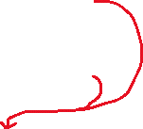

P(E F) = P(E | F) . P(F) = P(F | E) . P(E)

🡪 P(E | F) = -------------> BAYES’S FORMULA OF 2 EVENTS

Bayes’s Formula:

* We will deal with a two-stage experiment in which we know the outcome of the 2nd stage are interested in the probability that a particular outcome has occurred in the 1st stage.

Example:

* We are interested in finding out some patients probability of having a liver disease if they are an alcoholic.
* “being an alcoholic” is the test for liver disease.
  + A could mean the event “Patient has liver disease”. Past data tells you that 10% of patients entering your clinic have liver disease. P(A) = 0.10
  + B could mean the test that “Patient is an alcoholic”. 5% of the clinic’s patients are alcoholics. P(B) = 0.05
  + You might also know that among those patients diagnosed with liver disease, 7% are alcoholics. P(B | A) = 0.07
* Bayes’s theorem tells you:
  + P(A | B) = = = 0.14
* If the patient is an alcoholic, their chance of having liver disease is 0.14 (14%)

Example:

* 8% of the population has a disease
* A new blood test for detecting the disease researcher evaluate its effectiveness.
* New blood test detect 95% of sick people, 3% false correct (people actually don’t have disease)
* Suppose a person is selected at random and given the blood test.
* If the result is positive, what is the prob. that person has the disease?
* --------------------------------------------------------------------------------------------------------------------------------
* D1 = {having the disease}
* D2 = {not having the disease}
* T1 = {test +}
* T2 = {test -}
* D1 – D2 and T1 – T2 are complements
* We are given:
  + P(D1) = 0.08
  + P(D2) = 1 – 0.08 = 0.92
* P(T1 | D1) = 0.95 🡪 P(T2 | D1) = 1 – 0.95 = 0.05
  + 0.95 is probability that test is positive given person is sick.
* P(T1 | D2) = 0.03 🡪 P(T2 | D2) = 1 – 0.03 = 0.97
* P(D1 | T1) = ?
* 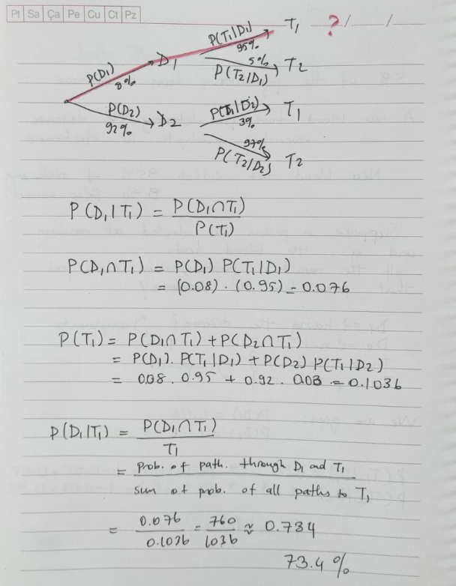



* 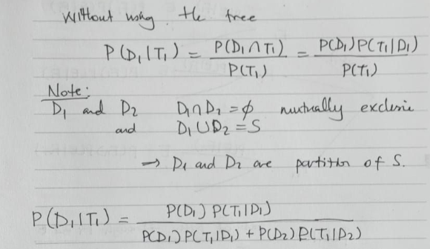

partition means you can separate the whole population in 2 distinct sets that have no intersection.

Bayes’s Formula:

* Suppose F1, F2, …, Fn are n events that partition a sample space S. That is, the Fi’s are mutually exclusive and their union is S. Furthermore, suppose that E is any event in S, where P(E) > 0. Then the conditional prob. of Fi given that event E has occurred is expressed by:
  + P(Fi | E) = For each value of i = 1, 2, 3, …

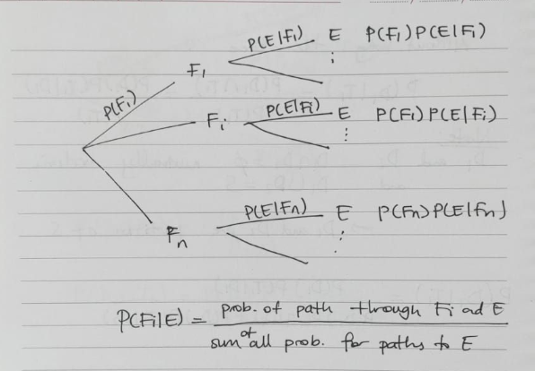

Each branch of tree is actually corresponding to a conditional probability.